UTILITY TRACK VEHICLE
Self propelled 4 wheeled Vehicle used at sites of Track laying and renewal on broad gauge rail routes for quick removal of surplus and scrap materials.
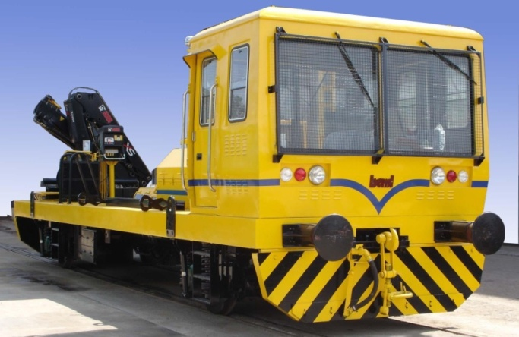
Salient features:
- Four wheeled vehicle self propelled by diesel engine with hydrodynamic transmission, axle drive
- Driving Cabin with controls for bi-directional operation
- Crane of knuckle boom type three stage telescopic with capacity of 1 Tonne @7.5 mtrs from buffers end
- Capable of hauling 90T Trailing lead

Max Speed  Tare Weight | 80 Kmph  22 Tonnes
Engine  Type  Power | NTA 855L CUMMINS, 6 cylinders inline, water cooled  400hp @ 2100 rpm
Transmission  Type  Gear Shift | CRT 5633 Hydrodynamic Transmission with Torque Converter  Electro Pneumatically controlled
Brakes  Service Brake  Emergency Brake  Parking Brake | Compressed Air Brake Gradual Application Gradual Release  Applied through Separate Emergency Brake Valve  Air Assisted spring brake chamber
Wheel & Axle  Wheels  Axle Capacity | 915 mm (new), Solid Forged  20 Tonnes(max), Two powered Axles, connected by Cardan shafts to the drop gear Box/Transmission
Suspension | Helical Spring with guide tubes & shock absorbers.
Crane  Lifting Capacity  Max out Reach/ Lifting Capacity  Slewing speed | 1 Tonne @ 7.5 meters from buffer end  10.3 meters/880 kgs  15 deg / sec
Dimensions  Length  Width  Height | 10850 mm  3200 mm  3650 mm

