8W-DHTC : 8Wheeled Diesel Hydraulic Tower Car
Purpose: Inspection and Maintenance of Railways’ OHE system.
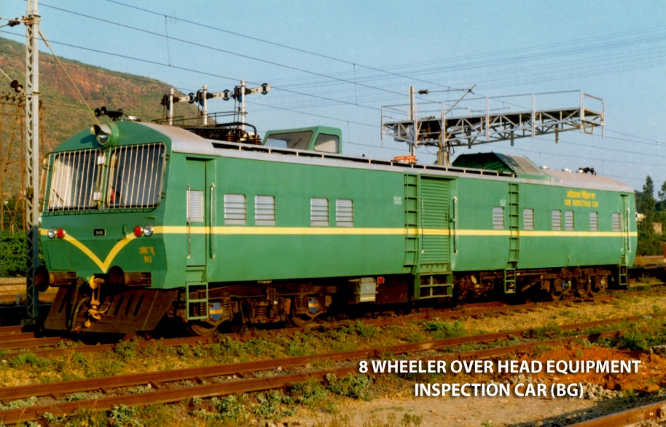
- Dual Power Pack
- Meant for periodic inspection, patrolling and maintenance of overhead equipment on electrified broad gauge rail routes
- Used to attend sites of breakdown of overhead equipment
- Capable of erecting and restoration of damaged small lengths of catenary and contact wires
Functionalities:
- Drivers Cab at both ends
- Staff cabins
- Kitchenette
- Workshop
- Lifting & Swiveling Platform (Hydraulic)
- Observation Dome
- DG Sets
- Cable Drum Mounting Brackets
- OHE Mast Guides
- Roof mounted pantograph for checking OHE parameters
- Intercom facility between Driver cab and lifting platform
Track Data | Rail Gauge |  |  | 1676mm
 | Minimum  Curve Radius |  |  | 175 mtrs
 | Maximum Gradient |  |  | 1 in 100
Basic Specifications
 | Gross Weight | 62.00 tonnes
 | Hauling Capacity | Self weight of 62tonnes with 60tonnes trailing load.
 | Maximum Operation Speed 110 kmph
Car Body  Dimensions in mm | Length over body  Width over body  Height from rail to  top of roof: |  | 8,500  3,200  4,260
Engine | NT 855 R 6 of Cummins; 213 kW (285HP) @ 2,100 rpm
Transmission | Fully Automatic hydrodynamic transmission Type: SANCRT UP102 (with AVTEC CRT 5633)
Final Drive | Axle Mounted Helical Gear Box (double reduction)
Axles | Solid forged, 16 Tonne Capacity one powered Axle (powered by one power pack) and one trailing Axle in each bogie.
Brakes | - Compressed air brakes with Tread brake units  - Gradual application and gradual release type applied on all wheels  - Pneumatically operated
Bogies | Two stage helical suspension with box section fabricated frame
Supplied | Above 100Nos.

