TRACK LAYING EQUIPMENT

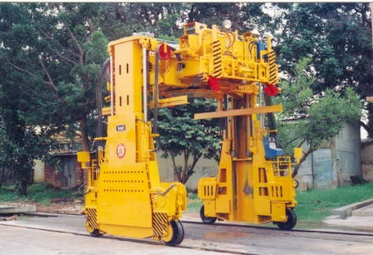
Lifting Capacity | 9 Tonne
Max. Lift of Rail Clamp | 2,900 mm from Ground Level
Engine  Make / Model Power | Kirloskar Oil Engine Limited (KOEL) / HA 694  79 kW (106 hp) ~ 2,300 rpm
Drive System | Hydraulic Drive Provided by Engine Driven variable  Displacement Pump to Wheels through Hydraulic  Motor and Chain, forward and reverse Drive Possible
Rail Clamps | Panel Lifting done by 4 Independent Scissor  Mechanisms Operated by Hydraulic Cylinders·
Sleeper Grippers | Hydraulically Operated Angle Grippers Provided for  Loading and Unloading of Concrete Sleepers
Brakes | Hydraulically Operated Shoe Brakes on all 4 Wheels  Actuated by Hydraulically Operated Valves, Parking  Brake on all 4 wheels
Weight of Equipment | 12,000 kgs
Max. Speed | 14 Kmph
Dimensions (in mm)  Length  Width | 3,100 (including Bridge)  3,860
Height  Track Gauge | 2,560 (Bridge Lowered)  3,400 (Auxiliary Track Gauge)

