Treasury Van (Operated on Mainlines of Indian Railways)
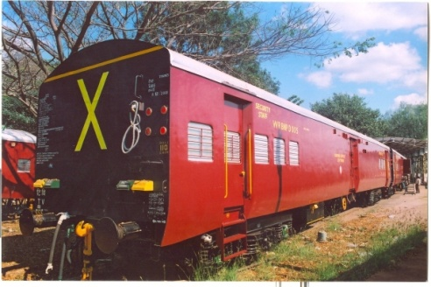
- Bullet proof paneling resistant to ballistic attack up to threat level-II
- A foot operated switch & Door Limit Switch for security Alarm system..
- Emergency feed terminals at both the ends
- Magneto generator type intercom facility
- Provision for CCTV camera
- Mobile Charging sockets in security staff compartment
- Smoke detector in the staff compartment on both sides & Treasury Compartment
- Hand operated Portable searching Lights
Track Data | Rail Gauge |  |  | 1676mm
 | Minimum  Curve Radius |  |  | 175 mtrs
 | Maximum Gradient |  |  | 1 in 100
Passenger Capacity |  |  |  | To seat : 10  To sleep : 14
Basic Specifications
 | Axle capacity | 16.25 tonnes
 | Tare Weight | 41.00 tonnes
 | Wheel Diameter | 915 mm
 | Maximum Operation Speed 105 kmph
Car Body  Dimensions in mm | Length over body  Width over body  Height from rail to  top of roof:  Wheel base  Distance between  bogie centers: |  | 21,336  3,250  4,025  2,896  14,783
Bogie & Driving  Gear Unit | - Bogie Type  ii) Suspension  · Primary & · Secondary |  | All coil Light weight high corrosion resistant Bolstered bogie  Helical Spring
Insulation | Material: Double side aluminium clad Glass Wool
Floor Covering | Material: Rubber on living area / steel chequered plate on storage area
Customer | Bharatiya Reserve Bank Note Mudrana Pvt. Ltd
Coaches Supplied | 30 Nos. (as on 31-Mar-2012)

