4Wheeled-OHE Car (Inspection and Maintenance of Railways’ OHE )
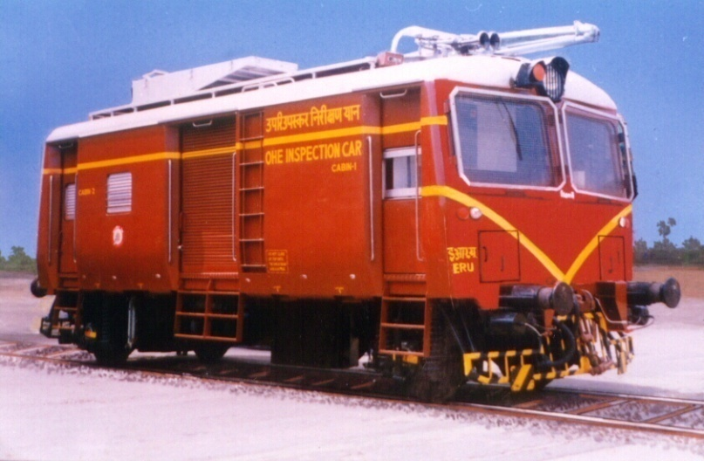
- Meant for periodic inspection, patrolling and maintenance of overhead equipment on electrified broad gauge rail routes
- Used to attend sites of breakdown of overhead equipment
Functionalities:
- Drivers Cab at both ends
- Lifting & Swiveling Platform (Hydraulic)
- Material Storage Space
- Work Bench
- OHE Mast Guides
- Roof mounted pantograph for checking OHE parameters
- Intercom facility between Driver cab and lifting platform
Track Data | Rail Gauge |  |  | 1676mm
 | Minimum  Curve Radius |  |  | 175 mtrs
 | Maximum Gradient |  |  | 1 in 100
Basic Specifications
 | Gross Weight | 32.00 tonnes
 | Tare Weight | 22.00 tonnes
 | Maximum Operation Speed 75 kmph
Car Body  Dimensions in mm | Length over body  Width over body  Height from rail to  top of roof: |  | 8,500  3,200  4,260
Engine | NT 855 R of Cummins; 152 kW (205hp) @ 2,100 rpm
Transmission | Automatic Hydrodynamic with KTC 100.20,  Power Shift Electro-Pneumatic Gear Shift
Final Drive | Axle Mounted Helical Gear Box
Axles | Solid forged, 16 Tonne Capacity one powered Axle and one trailing Axle.
Brakes | - Compressed Air Brake  Service Brake: Self lapping, Gradual Application Gradual Release  Emergency Brakes: Relay Emergency valve in service brake system and separate back up emergency Brake valve.  Parking Brake: Air Assisted Spring brake chamber
Suspension | Single stage with Vertical Guide arrangement having  Helical Spring and shock absorbers
Supplied | 10Nos.

