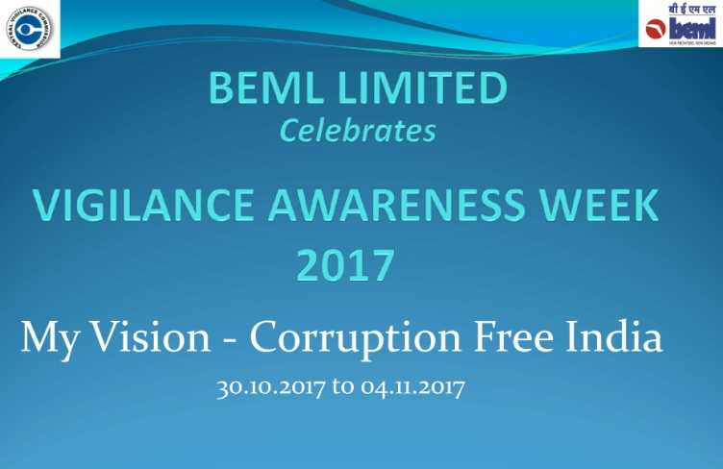***Vigilance Awareness Week***

***Be a part of Fight against Corruption.***

***Take Integrity Pledge”***

[***https://pledge.cvc.nic.in/***](https://pledge.cvc.nic.in/)